Q1.How can you output “Physics” and “Wallah” in two different lines

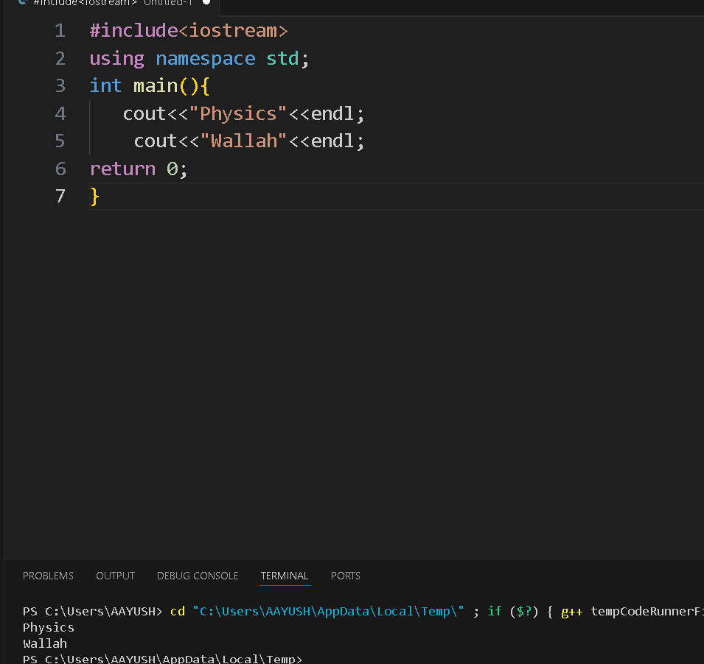

Q2. Print 10 using two positive number less than 6 in C++ as output
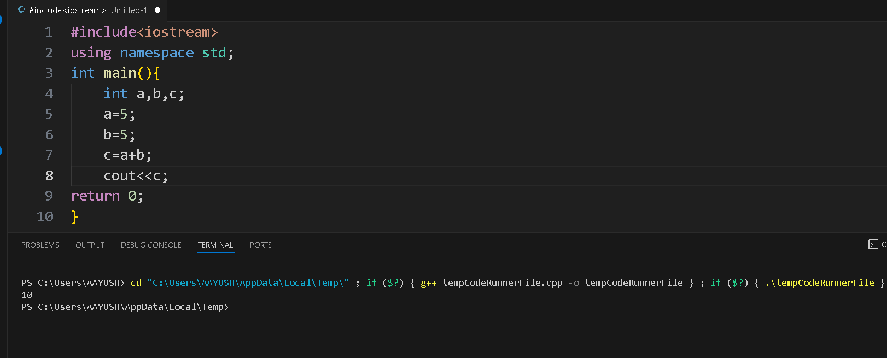

Q3 . How much space does following data types take.
- int = 4 bytes
- bool= 1 byte
- float= 4 bytes

Q4.What is the output of this program.
void main(){
int a=4;
int b=5;
a++;b--;
cout<<++a<<” “<<b--;
}

It gave an error because it returns an int .

Q5.WAP to find the circumference of a circle with radius 10 in C++.

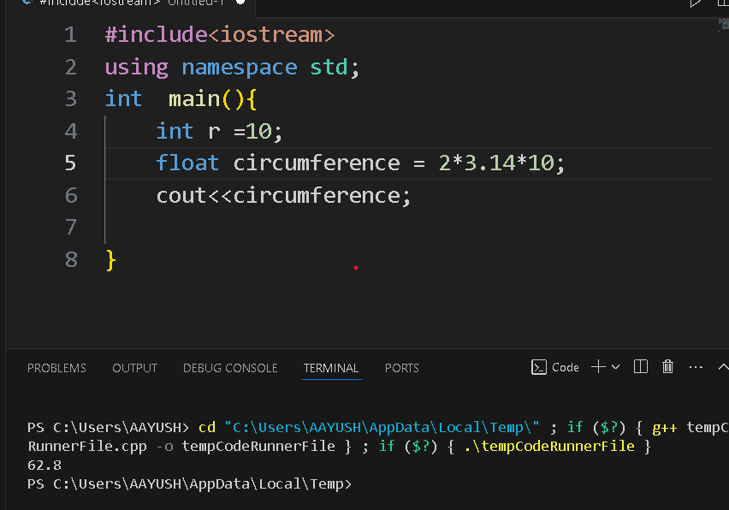

Q6. How many of these can be a variable name.
01PWskills
_Float
Int
Float
You will succeed

1

